Nutritional Discordance
Lila Cardell and Erin Lentz

Introduction

Women and girls are commonly assumed to be at greater risk of food insecurity (e.g., UN Women 2012). Earlier research examined whether women consume a lower percentage of their required daily caloric intake (e.g., Haddad and Kanbur (1990); Berhman and Deolaliker (1990); Pitt et al. (1990); Haddad et al. (1995)), but, as Marcoux (2002) summarized, “evidence of pro-male biases in food consumption is scarce” (p. 275).

In recent years, as nutritional measures have moved away from caloric intake, this claim has been reconsidered. More recent findings suggest that there is meaningful nutritional inequality within households. Much of the earlier research used caloric intake measures. Recent research has focused on richer nutritional intake and outcome measures, such as dietary diversity (Mangyo 2008; Villa et al. 2011; Rahman 2013), nutrient adequacy (Coates 2017 and Coates 2018), and body mass index (Sahn 2009; D’Souza and Tandon 2018). This resurgent interest in understanding intra-household nutrition reflects the recognition that calories are just one measure of nutritional status.

New studies measuring differences in nutritional status within households, which we refer to as nutritional discordance, find …

It is likely numerous attributes, such as cultural and social norms and institutions influence the degree of nutritional discordance across study sites. However, studies use both a wide variety of methods and a wide variety of nutritional measures to come to these conclusions. As a result, such findings are not directly comparable, and we have less sense of whether the degree nutritional discordance we observe is an artifact of the measures used or reflects the underlying data. The objective of this paper is to disentangle how the choice of method and choice of nutritional measure impact findings for a single country: Bangladesh.

Currently, researchers are required to make a series of choices about how to measure discordance, and there is little-to-no consensus on best practice. For example, some approaches ignore activity intensity of each individual. Individuals working in higher-intensity occupations may have greater caloric requirements compared to those who do not. If men are expending a greater proportion of energy in high-intensity activities than women, failing to account for energy expenditure can make results appear more inequitable than they truly are. The nutrient-reference tables used in low-income country studies also differ. In some cases, USDA reference tables are used, even though the foods’ nutrients may vary (e.g., sweet bananas in the US differ from staple bananas in Uganda). As a result of this variation, we know little from current studies about whether findings of nutritional discordance are sensitive to the choice of method or measure.

This research has two aims. First, we make a methodological intervention to learn the extent to which measurement choice influences findings of nutritional discordance. This can help us to determine when and where relying on unitary models of households is appropriate. Where appropriate, collecting household level data rather than individual level data can result in significant time and cost savings. However, a risk of assuming unitary households is that we misidentify the number of food insecurity individuals and the severity of the insecurity experienced. Brown et al. (2017) argue there is “substantial intrahousehold inequality” in sub-Saharan Africa, where being an undernourished woman is only weakly correlated with poverty status. Lentz et al. (2019) show that women eat last and least and consume fewer high-quality quality foods than other household members in rural South Asia. These and other studies raise questions about the continued reliance on unitary household models for food, agriculture and nutrition research. An important step is to identify how sensitive results that are discordant are to the choice of method.

Second, based on our findings, we aim to provide guidance on best practices for measurement. A better understanding of nutritional discordance is critical for food, agriculture, nutrition, gender, and social protection policy. For example, while efforts to link agriculture-to-nutrition remain widespread, achieving improved nutrition remains challenging (see Kadiyala et al. 2014). Similarly, an expanding interest on women’s empowerment (e.g., Pratley 2016; Santoso et al. 2020) raises questions of when and how gender inequality manifests itself within households. A clearer understanding of how to measure such effects, and when it is useful to do so can help researchers and practitioners recognize when household bargaining matters and how to design program interventions better achieve desired impacts.

In the next section, we describe the methodological choices researchers face when computing nutrient intake for household and individual level survey data. In section 3, we describe our data and present our summary statistics. In section 4, we share results, including the sensitivity of the nutrient intake to the various approaches and parameter choices. We conclude in section 5 with a discussion. By identifying relationships between measures, approaches, and parameters, we aim to make recommendations for best practices for measuring nutritional inequality, given data and temporal limitations.

Methodology

Researchers face multiple decisions points when computing nutritional discordance. In theory, the goal is to identify how many and which foods (and therefore macro and micronutrients) each household member consumed and compare those amounts against other members’ intakes within a household. However, to engage in this comparison requires multiple choices, such as whether and how to adjust intake requirements by activity level.

Using Bangladesh as a case study, we show that from the initial selection of data to the final inequality measure, these choices influence research outcomes. Figures 1 and 2 map the pathways for research starting with household level survey data and individual level survey data, respectively. The rectangles indicate possible decision-points, where researchers face choices regarding (1) which food composition table to use and how to adjust for bioavailability and retention (2) which individual nutrient requirements to use and how to adjust them to reflect life stage and level of physical activity and, (3) in the case of household data, how to convert the nutritional needs of household members into adult equivalents. We discuss each of these decision points and the figures in greater detail below. The numbering of each section corresponds with the pathways in Figures 1 and 2.

1. Survey Data:
In Figure 1, the first step is to distinguish two different data sources: household expenditure and consumption surveys (HCES) and household food diaries. HCES report household recall of purchases of food and non-food items and consumption over a set time period, often 7 days. Household food diaries typically track food intake over a 24-hour period. Household budget surveys, Living Standard Measurement Studies, Comprehensive Food Security Assessment Surveys are all examples of HCES.
Factors that can affect the quality of the results of a HCES include the length of time covered by the survey, the types of categories or options provided to the enumerators, the likelihood of food consumed away from home, and the level of literacy and urbanization of the household (Fiedler, et al. 2012). In sum, these surveys are widespread, but not without error. Comparisons of HCES and household food diaries have found that they are comparable in their collection of relevant consumption data (Fiedler, et al. 2012).

While HCES and household food diaries are less costly and easier to collect than individual-level survey data, they provide little or no information on how most food items are apportioned in the household. (Murphy, et al. 2012, Fiedler, et al. 2012, Sununtnasuk and Fiedler 2017). As a result, findings from household level survey data must make assumptions about who is eating what. In places with significant intrahousehold dietary inequality (e.g., see Lentz et al. 2019 describing gender-differences in consumption in rural South Asia), there is a significant risk of understating nutritional discordance.

Figure 2 demonstrates the pathway beginning from individual level survey data, which can be in the form of consumption diaries or recalls or observed food weight records (OFWR). Considered the gold standard for individual consumption data: OFWR capture video or photo of food consumed and allow the researcher to determine the quantity and quality of the food, while their cost makes them difficult to implement at scale (Fiedler, et al. 2012, Lividini, et al. 2013). Individual consumption diaries or recall surveys often ask the respondent to identify consumption over a 24-hour period. This short time frame can miss day -to-day variation in consumption patterns or preferences that can only be seen with a longer survey period (Murphy, et al. 2012).

A final source of nutritional discordance data is anthropometric measures of individual heights and or weights, or biomarkers serum to measure nutrient status. The cost of administering these tests and the training necessary to implement them are non-negligible (Murphy, et al. 2012). On their own, anthropometric findings can identify discordance; however, identifying whether food intake may contribute to these discordance measures requires additional data collection.

2. Food Composition Tables:
Food composition tables (FCT) are used to convert the food items reported in the dietary data sets into energy and nutrient values. Chemical analyses determine the nutrient context of the foods in the food composition tables (CITE). The United States Department of Agriculture, for example, provides a comprehensive database FoodData Central which contains data on food and nutrients for both items prepared at home or away from home. This database has been used extensively for non-US based research (e.g., Bermudez, et al. 2012, Lividni, et al. 2013) However, the quality and nutritional profile of foods can vary both across and within countries. For these reasons, research in non-US countries, it may be preferred to use regional food composition tables, which may provide greater accuracy in nutrient content and availability and may contain the local names of items to increase likelihood of identification (Behrman 1998, Sununtnasuk et al. 2017, Coates 2018, D’Souza and Tandon 2019). Finally, a combination of food composition tables may be required to identify all consumed items, as well as to standardize food sizes and quantities. Adjustments can also be made for bioavailability of nutrients and cooking retention factors (Coates 2017, Karageorgou, et al. 2018). The differences in bioavailability are more significant for minerals such as iron and zinc. (Allen, 2019)

3. Reported household or individual consumption for each nutrient:
The household or individual level consumption data is then matched to the food composition table(s). FAO provides the “FAO/INFOODS Guidelines for Food Matching” (2012) which recommends checking the name and description of the food item, as well as the scientific name, water and fat content. The form of the food that it is reported: fresh, dried, cooked, raw, etc. will affect how the food composition table is applied. If the reported item is a cooked dish, the USDA (2007) provides tables of nutrient retention factors that can be used to adjust the nutrient composition from raw to cooked form. Often, adjustments must be made if the survey data if presented in a different unit than the food composition table. After the survey food items are matched to data in the food composition tables, this yields the total reported nutrient consumption by the household or individual.

Note: Figures 1 and 2 show that the type of survey data available (household or individual) will change the calculation of nutrient intake. If using individual level data, the reported individual consumption can be compared directly to the nutrient requirements. If using household level data, additional steps must be taken to derive the allocated individual consumption of the nutrient, which is then compared to individual nutrient requirements. The process of deriving the allocated individual requirement relies on the requirements themselves. However, once individual nutrient intake is computed, the prevalence and intensity of inadequacy can be calculated by comparing the individual reported or allocated consumption of the nutrient to the nutrient standard.

4. Identification of Energy and Nutrient Requirements:
The selection of nutrient requirement is the source of most variation in outcomes. There have been proposals to harmonize nutrient standards across countries and methodologies (Allen, et al. 2019), but there is not yet convergence. Researchers must choose (1) the nutrient(s) of interest, (2) the source of nutrient requirements, and (3) the appropriate reference standard for the group or individual, which includes decisions about incorporating attributes such as age, sex, physical activity level, life stage, and reference height and weight. More precision on these attributes increases the likelihood that the appropriate nutrient intake standard is used as a benchmark. For example, a sedentary woman aged 65 and five feet tall does not require the same nutrients as an 18-year-old, physically active six foot tall man. While some datasets do not include all pertinent information and therefore researchers are forced to use a reference group that fits the characteristics available, some researchers also make simplifying assumptions, ignoring, for example, activity levels. This section considers the basic information for identifying nutrient requirements. In step 8, we discuss the specific process of determining nutrient inadequacy. We investigate the influence of such decisions in the results section.

Requirement type
Energy requirements, are denominated in kilocalories (customarily called “calories” or “kcal”) or kilojoules. Nutrients are compounds in foods which are used by the body for growth, maintenance, and energy and can be separated into two categories: (1) macronutrients, which are nutrients that the body requires in large amounts and typically denominated in grams: proteins, carbohydrates, and fats, and (2) micronutrients, which are nutrients that the body needs in smaller amount and are typically denominated in milligrams, such as calcium, vitamin A, and iron, among others. The relationship between macronutrients and energy requirements is certain: proteins and fats provide 9 kcal per gram and carbohydrates provide 4 kcal per gram. (IOM, 2006.) In the case study, we consider the relationships between micronutrient, macronutrient, and energy inadequacy, as researchers often are often subject to data limitations and may want to use proxies.

Source of requirements standards
The Institutes of Medicine (IOM), a joint United States (US)-Canadian effort, published the Dietary Reference Intakes (DRI) in 2006, covering energy, carbohydrates, fats and fatty acids, protein, and amino acid requirements, as well as micronutrients. These are considered the gold standard by nutritionists, and are updated periodically. The US also posts dietary guidelines for recommended intake, although the US guidelines are used infrequently (Brown, et al. 2019).

Given that the DRIs were developed for and by the US and Canada, there is a reasonable concern over the applicability of these standards to global populations. However, there is no alternative as comprehensive with the respect to the range of nutrients, or as validated by the scientific community. The World Health Organization (WHO) in combination with the U.N. Food and Agriculture Organization (FAO), the U.N. Children’s Fund (UNICEF) and U.N. University (UNU) have developed and published energy requirements (FAO 2004) and recommendations for nutrient intakes for protein (2002), energy (2005), carbohydrates (2007), fats and fatty acids (2010), and vitamins and minerals (2004.) The WHO guidelines are a valuable resource for weight and height assessments and targets for global populations (Schenider and Hertforth 2020, Allen, et al. (2019). The WHO/FAO approach to identifying energy requirements is more commonly used, complemented by IOM standards for micronutrients, as the WHO/FAO requirements do not provide average requirements for all nutrients. (Bermudez. et al. 2012, Lividni et al. 2013, Sununtnasuk et al. 2017, Coates 2017).

The diversity in the weights, heights, and nutritional characteristics of different populations begs the need for regional requirements, which exist in selected countries. The National Institute of Nutrition (NIN) published Dietary Recommendations for Indians in 2011, which provide recommendations for protein, fat, calcium, and iron and energy intakes based on an average weight and height for sex, age, and life stage groups.

4a) Energy Requirements
The IOM defines the Estimated Energy Requirement (EER) as the “average dietary energy intake that is predicted to maintain energy balance in a healthy adult of a defined age, sex, weight, height, and level of physical activity consistent with good health.” The EER is also adjusted for the needs of children, pregnant and lactating women. (IOM, 2006)
The WHO/FAO approach to energy requirements for adults identifies a Basal Metabolic Rate (BMR) which is the “minimum energy expenditure that is compatible with life.” It is a function of weight for each age-sex group. The BMR is adjusted for pregnancy and lactation status and then multiplied by the Physical Activity Level (PAL) multiplier to obtain the Total Energy Expenditure (TEE), which is the “energy spent, on average, in a 24-hour period by an individual, or a group of individuals.” For children, the TEE equations are given by age and sex group, with and addition for energy disposition and a multiplicative adjustment for activity status: 15% lower for sedentary children and 15% higher for active children. (WHO, 2001)

The India NIN provides “net energy requirements” by sex, age group, pregnancy and lactation status, analogous to TEE. Activity level is taken into consideration when identifying energy requirements for adults over 18 years of age. These requirements were developed using the WHO/FAO methodology using reference weights and heights for the population of India (NIN, 2011)

Energy adequacy can also be assessed using Body Mass Index (BMI), which is the individual’s weight in kilograms divided by the square of the individual’s height in meters. For adults, the WHO defines healthy BMI within the 18.5-24.9 range. For children, the WHO provides BMI charts providing the distributions of BMIs for healthy growth standards. (WHO, 2006)

Physical Activity
Active individuals require more energy than sedentary. The delineation of individuals by physical activity level can affect the individual nutrient requirements and likelihood of an individual being identified as inadequate. All three reference sources adjust energy requirements based on classification of physical activity level. The DRIs provide 4 categories: sedentary, low active, moderately active, and high active and adjust energy requirements based on a multiplier for each category. The WHO/FAO requirements provide ranges of multipliers for adjusting energy requirements within low, moderate, and heavy categories. The Indian National Institute of Nutrition (NIN) requirements are provided separately for sedentary, moderate, and heavy activity for adults, with the assumption of moderate activity for children under 18. Some papers, either due to lack of data or as a simplification, classify all individuals as moderate (Karageorgou, et al. 2018, Coates 2017, Coates 2018, D’Souza and Tandon 2019), while others allocate activity category between “light”, “moderate”, and “active” based on occupation category. One resource is to identify the appropriate activity level by occupation as in Steeves et. al. (2015), who used accelerometry data collected in 2003-2004 from over 1000 adults in the United States, to allocate indiviuals into three groups based on occupation.

Life stage
Energy and nutrient requirements do not increase monotonically with respect to age. Children, pregnant, and lactating women have different energy and nutrient requirements and require adjustments to calculations. For example, protein and iron requirements for pregnant and lactating women differ than for other women. The IOM, WHO/FAO, and India nutrient standards all provide recommendations specific to life stage group. However, it is not always possible to identify from survey data whether an infant is fully or partially breastfeeding, or how far along a woman is in her pregnancy. One option is to eliminate all children under 2 years of age, and pregnant and lactating women (D’Souza and Tandon 2019, Brown, et al. 2019). Another is to estimate pregnancy and lactation status within a 3-6-month window and assign the average requirements for that window (Sununtnasak and Fiedler 2017).

Reference Heights and Weights
The IOM energy recommendations (and any nutrients that are a percentage of energy requirements) rely on incorporation of a weight, height, age, and physical activity level into equations given for each age, sex, and life stage group. The WHO/FAO energy requirements (and some nutrient requirements) rely on a weight and physical activity level for a given age, sex, life stage group. Thus, for IOM and WHO/FAO calculations, the choice of weight, height, and age can have a significant impact on energy needs. The energy and nutrient requirements provided by the Indian National Institute of Nutrition are given by age, sex, physical activity, and life stage group, for a set reference height and weight that is also given for that group.

When individual height and weight data are available, researchers can create individual-specific energy requirements by using the individual’s current weight and height. In cases where individuals’ heights and weights are not collected or as a simplifying assumption, the calculations for energy or nutrient requirements are made for the entire age, sex, and lifestage group using the reference height and weight given by the reference source. If activity or occupation data is available, the group-based energy requirement can be adjusted for individual physical activity level to estimate the individual energy requirement. (FAO,2006)

While IOM, WHO/FAO, and India all provide reference weights and heights for age, sex, and lifestage groups, the gold standard recognized by nutritionists are the WHO child growth standards. These standards were published in 2006 using measurements collected globally. The growth standards use measurements for children under 5 and then extrapolate growth references for children 5-19 years old. Heights and weights are given at a monthly level, in contrast to median heights and weights provide by IOM for age sex groups. (IOM, 2006; WHO, 2006) The median heights and weights for 19 year olds are assumed to represent final growth values, and are used as estimates for the median heights and weights for all adults. (IOM, 2006) The WHO did not provide adjustments for pregnant women, however. The IOM provided guidelines for recommended weight gain for healthy women during pregnancy, which can be used to adjust the WHO reference weights for pregnant women. (IOM, 2009)

4b) Nutrient Requirements
In general, the standards set forth differ across two dimensions: (1) whether the standards will be used assess inadequacy or safety of nutrient intake or if the intent is to make dietary recommendations, (2) whether the assesment or recommendation is being made at an individual or population level. We primarily focus on identifying individual or population level nutrient inadequacy, which is of interest to social scientists.

Types of Micronutrient Standards:
- Average Nutrient Requirement (AR): the average daily nutrient intake level that is estimated to meet the requirements of half of the healthy individuals in a particular life stage and gender group. The IOM and WHO/FAO calls this “Estimated Average Requirement” (EAR), but as of 2011, NASEM uses the term “Average Requirement” (AR). Although the AR can also be used to examine the probability that usual intake is inadequate for individuals (in conjunction with information on the variability of requirements), it is not meant to be used for recommending daily intake by individuals. The AR may be the mean or the median of the requirement distribution, which is the variability in a requirement across healthy individuals in the age, sex and life stage group. The intake distribution is the variability in nutrient intake for an individual. IOM provides EARs for most micronutrients. (IOM, 2006, 2011)
- Individual Recommended Intake: the average daily nutrient intake level that is estimated to meet the requirement of nearly all (97-98 %) of the healthy individuals in a particular life stage and gender group. The IOM calls this “Recommended Daily Allowance” (RDA) while WHO/FAO call it “Recommended Nutrient Intake” (RNI) and NASEM (formerly IOM) use the term “Recommended Intake” (RI). It is the AR + 2SD. The RDA thus exceeds the requirements of nearly all members of the group, and is not recommended for assessing the adequacy of intake for a group, as 97-98% of the population should meet the RDA requirement. It can be used as a guide for daily intake by individuals as usual intake at the RDA should have a low probability of inadequacy. If the RI/RNI/RDA cannot be determined, the Adequate Intake (AI) is used, which the IOM defines as the recommended average daily intake level based on observed or experimentally determined approximations or estimates of nutrient intake by a group (or groups) of apparently healthy people that are assumed to be adequate. The IOM provides RDA and AI for most micronutrients (IOM, 2006, 2011). FAO/WHO provide RDA or AI for some micronutrients, however they have not been validated or updated as closely as the IOM requirements.(FAO, 2001, 2004,2010) India provides RDAs for calcium and iron. (India, 2011)
- Tolerable Upper Limit (UL): the highest average daily nutrient intake level that is likely to pose no risk of adverse health effects to almost all individuals in the general population. As intake increases above the UL, the potential risk of adverse effects may increase. This standard is generally used for assessing the safety of dietary recommendations. (IOM, 2006, 2011)

A comparison of the various terms from Allen (2019) is included in the graph and Table 1: Summary of Nutrient and Energy Standards by Reference Source and Usage
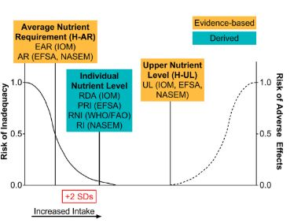
Types of Macronutrient Standards:
- Acceptable Macronutrient Distribution Range (AMDR): The range of intakes of an energy source that is associated with a reduced risk of chronic disease yet can provide adequate amounts of essential macronutrients. The AMDR is expressed as a percentage of total energy intake and therefore varies with energy requirements which can be affected by age, sex, height, weight, activity level and life stage group. The AMDR must be converted to grams to be compared to reported or allocated intake levels, based on carbohydrates and protein providing four calories per gram and lipids providing nine calories per gram. The key feature of each AMDR is that it has a lower and upper boundary. Intakes that fall below or above this range increase the potential for an elevated risk of chronic diseases and raise the risk of inadequate consumption of essential nutrients. IOM provides ranges for carbohydrates, protein, and fat intake, by age, gender, and life-stage group. (IOM, 2006)
- Depending on the source, an average requirement (AR) or individual recommended intake (RI) may be provided for the macronutrient. IOM provide EARs for protein and carbohydrates that vary with weight. (IOM, 2006)
- Recommended Daily Allowances (RDA) may also be available: India provides RDAs for protein and fat requirements. (India, 2011)

5. Adult Equivalents:
When consumption data is only available at the household level, various methods are used to assign representative shares to individuals to allocate nutrient consumption. The easiest is the “per capita approach” which allocates calories or nutrients equally among all members of a household. However, this approach assumes that all household members consume the nutrient equally and misses out on household variation due to the different needs of children vs adults, for example (Karageorgou, et al. 2018). A second approach assumes that the share of household nutrient consumption allocated to the individual is proportional to individual nutrient requirements. In this approach, the individual’s energy or nutrient requirements must be identified using the nutrient reference standards. The individual’s “Adult Equivalent” (AE) is expressed as a ratio of the individual’s energy or nutrient requirement relative to the energy nutrient requirement for a base individual, typically an 18 to 30 year-old male with moderate physical activity level.

While an AE can be calculated for each nutrient individually, the AE generated by the relative share of energy requirement is typically used and applied to all nutrient allocations. Coates (2017) calculated nutrient-specific adult equivalents and found that the differences between shares were not significant when compared to using the AE value derived from energy consumption to identify shares for all nutrients.

6. The individual’s representative share %:
The representative share for an individual is equal to the individual’s AE as calculated above, divided by the sum of all adult equivalents in the household.

7. Allocated individual consumption of each nutrient:
Total household energy or nutrient consumption is multiplied by the individuals’ share % to yield the individual allocated consumption of energy and nutrients. This is the quantity of calories, macro, or micronutrient the individual is assumed to have consumed.

8. Application of Requirements to Measure Inadequacy:
Step 4 laid out the process for identifying the energy or nutrient requirements for an individual or group. This step describes the process for applying the requirements to identify inadequacy in individuals or groups.

8a) Energy Inadequacy

There are two issues in determining energy inadequacy related to whether requirements are calculcated using either individual body measurements or reference group-based measurements, as discussed in Step 4A. First, the choice of the which heights and weights are used to calculcate energy requirements can bias the likelihood of individual inadequacy, and second, the method of aggregating or averaging requirements or inadequacy can bias inference about group-based adequacy.

For calculating requirements: If using reference group measurements (median height and weight within an age, sex and lifestage group) to identify energy requirements, the same energy requirement would apply for everyone within the group, with possible adjustments for physical activity level. (Coates, 2017; Haddad, 1994) A challenge of using group-based reference heights and weights is that the requirement is a median, thus the requirement exceeds the needs of half of the individuals in the group and is inadequate for the other half. Using individual heights and weights to generate individual-specific energy requirements allows for individualzed assessment, if those measurements are available. (Sununtnask & Fiedler, 2017) However, if an individual’s weight or height is below or above the standard and is not considered “healthy” by nutritional standards, the energy requirement based on that height or weight might not be appropriate for maintaining health. Additionally, TEE/EER both represent midpoints of recommended energy requirements and therefore an individual’s mean intake could occur within a range, however the standard error of the TEE/EER is not always provided.

For determining inadequacy: As discussed in Step 4a, there is inconsistency in whether adequacy is determined by comparing actual or allocated intake to the requirement for the individual (based on their actual weight, height, age, lifestage and physical activity level) or comparing actual or allocated intake to the requirement for a reference individual for the individual’s age, sex, and life stage group. Both of these approaches often classify an individual as inadequate if they are below the requirement, with or without adjusting for intake or requirement variability. Inference at an individual level by comparing individual intakes to individual requirements and then averaging across an age, sex, lifestage group suffers from the bias noted in the calculation of individual requirements, as does any comparison of individual intake to a median or mean group intake requirement. Inference at a group-level relies on a variation of the cut-point method used for micronutrient intake assessment, by assuming that the proportion of the group below the intake requirement correlates with the prevalence of inadequacy. The cut-point method relies on the assumption that intakes and requirements are independent, which is unlikely to be true for energy intake: people feel hungry and so they eat more, reflecting accurate signaling and actions. IOM is clear that this assumption prevents application of the probability approach or EAR cut-point method for assessing energy adequacy of a group, but it is still used nonetheless. (IOM, 2006) The magnitude or intensity of energy and nutrient gaps is generally presented as the percentage below the requirement for the proportion of the group with inadequate intake. (Sununtnasak & Fiedler (2017), D’Souza and Tandon (2019)), however this is not consistent.

For all of the reason described above and others related to intake measurement and variability, IOM recommends using Body Mass Index (BMI) standards in lieu of energy intake. The BMI is equal to the individual’s weight in kilograms divided by the square of the individual’s height in meters, and provides a different representation of both energy intake and energy utilization. The WHO provides distributions for appropriate BMI standards by age and sex for all individuals. Observed heights and weights likely have less day to day variability compared to energy and the WHO distributions can be used to make inferences about prevalence of inadequate energy intake in a group. (IOM, 2006; WHO/FAO, 2006)

8b) Nutrient Inadequacy

Assessing Inadequacy of Micronutrient Intake:
For the goal of identifying individual or population level nutrient adequacy, the average requirement (AR) or estimated average requirement (EAR) is the most relevant nutrient standard. However, it is not available for all nutrients from all reference sources, and the method of assessing inadequacy is different between individuals and groups in theory, although not always in practice. As discussed in Step 4, IOM is the predominant and often sole reference source for micronutrient requirements, therefore this step describes the IOM approach to identifying individual and group-level inadequacy. The probability of inadequacy is a measure of an individual’s intake with respect to the distribution of requirements within the same age, sex, and life stage group. The prevalence of inadequacy measures the proportion of a group with intakes below requirements.

Using an EAR to assess the probability of inadequacy for an individual:
The difficulty in identifying inadequacy for an individual derives from two sources of uncertainty: the individual’s actual requirement, and the individual’s long-term typical intake. Therefore data on two distributions must be used: the variation in person-to person intake requirements within a age, sex, lifestage group, and the variation in day-to-day intakes for an individual. The DRIs provide these distributions. (IOM, 2006) A z-score can be calculated following the formula below, which is associated with the probability that an individual’s usual intake meets his or her intake requirement. However, this method requires multiple observations of an individual’s intake, which is unlikely in the type of survey data available to most social scientists and it requires that intakes and nutrient requirements are normally distributed, which is not true for all nutrients. (IOM,2006) The standard deviation (SD) of the nutrient requirement is the coeffient of variation of the nutrient times the EAR and the standard deviation of the within person intake has been estimated by the IOM.

$$z score=\frac{mean observed intake-EAR}{\sqrt{\frac{{(SD requirement)}^{2}+{(within person SD) }^{2}}{number of days of intake records}}}$$

In practice, a qualitative approach is often used: if the observed mean intake is less than the EAR, then it is likely that the individual’s intake is inadequate.

For nutrients with an AI because an EAR is not provided, the standard deviation of the requirement also does not exist. If multiple intake observations are available, a z-score can be created that adjusts for the within-person SD as above, by eliminating the SD of the requirement.. However, as it is unlikely that multiple intake records are available, a similar qualitative assessment can be made: if the observed intake is above the AI, than it is likely that the individual’s intake is adequate, but if an individual’s intake is below the AI, no qualitative or quantitative assessment can be made. The RDA should not be used to assess individual intake adequacy, as it is set at a level sufficient for 97.5% of the individuals in an age, sex, lifestage group. (IOM, 2006)

Using an EAR to assess the prevalence of inadequacy within a group:
For groups, there are three relevant distributions: the variation in person-to person intake requirements within a lifestage group, the variation in person-to person intakes within a lifstage group, and the variation in day-to-day intakes for an individual. First an adjustment is made to eliminate the variation in individual day-to-day intakes, so that the only remaining variation is among members of the age, gender, lifestage group. This adjustment requires at least two independent days or three consecutive days of dietary intake data for a representative sample of individuals in the group. If this data is unavailable, within-person variation can be estimated using variation in intakes derived from a similar dataset (Murphy, 2002)

For all nutrients with EARs that are normally distributed, the IOM recommends using the cut-point method, which assumes that the proportion of individuals with intakes below the EAR is consistent with the proportion of individuals with inadequate intakes of the nutrient. The cut-point method assumes intakes and requirements are independent (not true for energy), symmetrical (not true for iron), and that the distribution of intakes is more variable than the requirement distribution. For nutrients that are not normally distributed, such as iron, the probability method must be used, which averages probabilities (from z-scores) across individuals to estimate the prevalence of inadequacy in a group. This approach assumes that intakes and requirements are independent.

Iron
Iron requirements are affected by age, sex, reproductive stage, and use of oral contraceptives. (Schneider & Hertforth, 2020) Iron intakes can also be affected by regional difference in iron bioavailability in the diet, and a nutritionist should be consulted when undertaking iron inadequacy assessments.

For nutrients with an AI because an EAR is not provided, groups with mean intakes at or above the AI are likely to have a low prevalence of inadequacy, however mean intake below the AI yields no qualitative or quantitative inference. The RDA should not be used as a cut-point for group level adequacy, as it is set at a level sufficient for 97.5% of the individuals in an age, sex, lifestage group. (IOM, 2006)

Assessing Inadequacy of Macronutrient Intake:
For nutrients with an AMDR, similar z-scores can be constructed using the lower and upper bounds to generate inference for individual inadequacy. In practice, a qualitative assessment is made that observed mean individual intake within the bounds of the AMDR is likely acceptable. For a group, the proportion of the group that falls below, within, and above the AMDR reflect the proportion of the population that has intake below, within, and above the range of acceptable intake values. (IOM, 2006)

Identification of the extent of the inadequacy?
There is no consensus on measuring the magnitutde of the inadequacy in an individual or group.
Energ-adjusted intake relative to needs (Schneider) nutrient density? Adequacy ratios of total nutrient quantity divided by the nutrient requirement
Use median for group (and assume proportion

9. Nutrient Inequality Measures:

After energy or nutrient inadequacy has been identified, using a binary measure of frequency or continuous measure of extent, a researcher may want to make an inference about the relative inadequacy within a household, or across different groups of individuals, such as children vs. adults. There have been various approaches:
- If individual level data is available (as with the BIHS), the reported individual nutrient consumption can be compared to the allocated individual nutrient consumption to test whether the household is allocating nutrients by need. (Sununtnasak and Fiedler (2017), D’Souza and Tandon (2019)) This can be done using percentages of inadequacy, log deviations, or difference in deviations, z-scores or other unit free measures (e.g. expressing allocated inadequacy as a percentage of reported inadequacy.) Concordance correlation measures are also used to compare the consistency between allocated and reported nutrient inadequacy.
- For household level data, the frequency or intensity of inadequacy for individuals can be compared within a household or across population groups. Coates (2017) compared inadequacies for boys relative to girls, and children relative to adults. This can be done using percentages or z-scores for intensity of inadequacy, or other unit-free measures. An approach used by Berti (2012) used the relative dietary adequacy ratios, defined as
=energy adequacy ratio of group i (average intake of group i/average energy requirement of group i)/ energy adequacy ratio of the group of adult males
- Kuznets curves to consider prevalence of inadequacy with respect to self-measure, or to household level variables (i.e. income) (Sahn and Younger 2010).

Bangladesh Case Study

To compare across methodologies, we use the Bangladesh Integrated Household Survey (BIHS). BIHS is a rich, nationally representative survey collected in 2011-12 of over 21,000 individuals across more than 6500 households. These households were selected to be representative in 3 dimensions: nationally representative of rural Bangladesh, representative of the rural areas of each of the seven administrative divisions of Bangladesh, and representative of the zone covered by the Feed the Future (FTF) program funded by the United States Agency for International Development (USAID) and implemented by IFPRI. The FTF sample comprises 1000 households, which we exclude from our analysis. Sampling weights were provided for IFPRI for the remaining 5503 households. (Ahmed et.al. 2013) Within those 5503 households, we identified 21,442 individuals who were 2 years of age and older and had meal data available. Children under the age of 2 were excluded as identifying intake and nutritional requirements for breastfed children was beyond the scope of this paper.

Table 3 presents descriptive statistics for 5503 households included in the BIHS sample and are weighted to be representative of the rural population of Bangladesh using weights provided by the International Food Policy Research Institute (IFPRI), which participated in data collection. Adults are defined as individuals 18 years old and over and represent more than half of all household members. Food purchases represented 57% of weekly household expenditures. The average household has a household dietary diversity score of 8.4, which means that the average household consumes between 8 and 12 of the following food categories on a weekly basis: cereals, roots and tubers, vegetables, fruits, meat (including poultry), eggs, seafood, pulses and legumes, milk and dairy products, sugar, fats, and miscellaneous items.

Statistics for household heads and spouses are included. Nearly all households are headed by married men. Approximately 50% of both heads and spouses are not literate and or have had no schooling. Secondary schooling is uncommon, and over half work in agriculture. The Body Mass Index is 20.24 for household heads and 20.85 for spouses, which is within the range of what is considered healthy by IOM, WHO/FAO, and NIN standards. Reported daily calorie consumption is approximately 2500 kcal on average for household heads, and 2100 kcal for spouses.

In what follows, we show how each decision point in Figures 1 and 2 influence findings.

1. Household and Individual Consumption Data:
The uniqueness of the BIHS dataset is that it provides information on both household food consumption and individual shares of foods consumed. First, the BIHS includes a module of “menu items,” which report the type and weight of all foods (including individual ingredients and multi-ingredient dishes) consumed by the household over a 24-hour period. For multi-ingredient dishes, the dataset lists the type and weight of all raw component ingredients. The cooked weight of the dish is reported. The second module of “meals” lists all meals served in the household during the same 24 hour period, and the quantity of each menu item (both individual ingredients and prepared dishes) that each household member consumed at each meal. Meals taken away from home and portions of meals consumed by guests, pets, or discarded are included in this data set, and can be adjusted for accordingly. A separate module asks about food consumption over the prior seven days, reporting the quantity consumed by the household and the acquisition source (purchase, produce, gift, etc.) This dataset could be used to validate whether the consumption reported in the 24 hour dataset is representative of the typical diet of the household, but adds no further information on individual consumption. Another module reports frequency of consumption for a select 17 food groups, which we use to derive the household dietary diversity index.

2. Food Consumption Tables (FCT):
For the case study, we used two food consumption tables primarily: a food consumption table provided by the Institute of Nutrition and Food Science at the University of Dhaka in Bangladesh, and another by the National Institute of Nutrition of India. The former was assumed to be closest to the food items included in the BIHS dataset, specifically with respect to foods identified in Bengali. The second data set was used for items that could not be clearly identified from the Bangladeshi FCT, and was a reasonable resource with respect to regional similarities in food items and nutritional characteristics. Lastly, for any items not available in those datasets, for example, purchased items such as Horlicks, a packaged drink powder, the USDA food database was consulted. All FCTs listed the following per 100 grams: energy (kilocalories), macronutrients (protein, carbohydrates and fat, all in grams), and micronutrients (iron and calcium, in milligrams.)

3. Reported household or individual consumption for each nutrient:
First, we matched the “menu items” module containing the quantities of food items (individual ingredient and multi-ingredient dishes) with the FCTs described above. The quantity of energy, macro and micronutrient for each food item was calculated by using the nutrient data reported in the FCT per 100g and adjusting to the reported quantity (in grams) of the food item in the module. For dishes reported without component ingriedients, or with missing nutrient values, we imputed nutrient values for the dish using the median value per 100g for that dish reported by all other households. Overall, we winsorized the value per 100 g for each food item (single-ingredient and mixed dishes), ie: if the value per 100g was above 95% of the per 100g value reported by all households, it was replaced by the 95% value, and similarly for the lower tail.

After nutrient data has been identified or calculcated for all items in the “menu items” module, this module is matched to the “meals” module, which reports the quantity of each food item (ingredient or multi-ingredient dish) consumed at each meal by each household member, guests, pets, or discarded. The total calories, macro and micronutrients consumed that day the household can then be determined by summing over all meals, to calculate the “Reported Household Consumption of the Nutrient,” which is denoted by the blue diamond “3” in the flowchart in Figure 1. If no individual share data was available, this would be the only feasible pathway for our analysis. However, the BIHS provides the individual share data, and we can allocate the total calories or nutrients for each dish to each individual by the relative share of the dish consumed by that individual. Then, we take the sum of all calories and nutrients allocated to the individual within the 24 hours period to generate the “Reported Individual Consumption of the Nutrient,” which is denoted by the orange diamond “3” in the flowchart in Figure 2. Children under 2 years old were eliminated from the data set, as it was unknown the quantity and frequency of breast-feeding, and relative share of nutrients to consumed food.

4. Energy and Nutrient Requirements

Requirement type:
We focus on individual and group level inadequacy of energy, macronutrients (protein, fat, and carbohydrates), and two selected micronutrients (calcium and iron)

Requirement source:
We consider requirements from IOM, FAO/WHO and NIN references for energy and nutrients. (IOM, 2006; IOM, 2011; FAO/WHO, 2006; NIN, 2011)The specific requirements available by source are listed in Table 2. As we are primarily interested in individual and group level inadequacy, we focus on energy requirements using EER and TEE, as well as BMI, which are present in all three reference sources, albeit only at the group level from NIN. For nutrient, we focus on requirements that have an EAR or AMDR, as both can be used to infer individual and group level inadequacy, as described in Table 1. While India and WHO/FAO provide RDAs for some macro and micronutrients, RDAs have limited utility in assessing inadequacy because they are intended to be set at a level that meets the needs of 97.5% of healthy populations. For individuals, usual intake at or above an RDA implies a low probability of inadequacy, but no conclusions can be made for intake below the RDA. For groups, it is not possible to apply an RDA as by definition, it meets or exceeds the requirements for 97.5% of the population and thus would overstate the extent of inadequacy in a group. For all macro and micronutrients with an RDA provided by FAO/WHO or NIN, an EAR and/or an AMDR is provided by IOM.

4a) Energy requirements
Lifestage
All three reference sources provide adjustments to energy requirements for pregnant and lactating women, often by the term of pregnancy, or months post-partum for lactatation. However, this level of specifity is not always available in datasets, including in the BIHS. Therefore, we take averages of all additional requirements for pregnancy and lactation status: The requirements provided by the NIN allot an additional 350 calories per day for pregnancy and 560 calories per day for lactation. WHO/FAO energy requirements allot an additional 285 calories for pregnant women on average, and and average of 485 additional calories per day during lactation. IOM requirements allot an average of an additional 340 calories per day during pregnancy and 330 calories per day during lactation. We excluded all children under the age of 2 to avoid consumption allocation for partially breastfeeding children.

Physical Activity
The BIHS dataset provides information on occupation, which we used to allocate individuals based on occupation category as light, moderate or active. We relied on recommendations from Steeves et al. (2015), who used accelerometry data collected in 2003-2004 from over 1000 adults in the United States, to allocate individuals into three groups based on occupation. IOM provides a recommended physical activity (PA) multiplier for four groups of activity levels, which we used, although it could be adjusted within each activity category. The WHO/FAO calculcations provide a range of PAL multipliers for adults, we selected the lowest point in the range provided, consistent with prior research using the BIHS data set (Sununtnask and Fiedler 2017, Le Roy, 2018). The NIN energy data is provided for by age, sex, and lifestage reference group with three activity designations for adults, and cannot be adjusted further. All children are assumed to have the same moderate activity level for NIN calculations.

Reference Heights and Weights
Table 3 presents data on the reference heights, weights, and relative consumption shares for the sample. Height and weight are used to determine energy requirements for the IOM energy requirements and for AMDR nutrient requirements that are calculated as a percentage of the energy requirement. The FAO/WHO requirements rely on weight only, and the India requirements are provided for a reference height and weight for each age and sex group.

Age-sex groups are presented, with the weighted average of the individuals in that group. “Sample” weight and height refers to the weighted average weight and height of individuals in the data set, while “Reference Standard” refers to the weighted average of weights and heights assigned to each individual by age, sex, and life stage group for each of the three standards (“India”, “WHO/FAO”, “IOM.”). We follow Schneider and Hertforth (2020) in adjusting WHO/FAO and IOM reference weights for pregnant women using the median reference weight and the midpoint of the IOM recommendation for weight gain during pregnancy: 13.75 kg. (IOM, 2009)

Across age-sex groups, the weighted average weight is lower than any of the reference standards. The weight reference standards for WHO/FAO and IOM are similar, and larger than the reference standards for India in all cases. For height, there is significant variation between the IOM and WHO/FAO standards for children under the age of 18. The discrepancy in reference heights can have a significant impact on the determination of energy requirements.

4b) Nutrient requirements
As discussed in Section I, the IOM nutrient requirements are the standard, based on the rigor of the methodology to derive the requirements, and the availability of requirements for micro and maro nutrients. We consider all three macronutrients: protein, carbohydrates, and fat, and two micronutirents: calcium and iron. The impact of individual compared to reference group measurements has been demonstrated through the variation in energy requirements, therefore for micronutrients, we use only group-based reference heights and weights for calculations that incorporate body measurements.

Macronutrient requirements
For protein requirements, we use EARs provided by WHO/FAO and IOM which are given per kg of body weight, and thus can be calculcated both for an individual weight and for the reference group weight. Both sources provide requirements by age, sex and life stage group with adjustments for pregnancy and lactation, with WHO requirements provided by year for children under 18. (WHO, 2002) The WHO provides additional daily requirements for each trimester of pregnancy and months post-lactation, which are not based on weight; we use the average of each set of requirements. (WHO, 2002) The IOM provides higher per kg per day requirements for pregnancy and lactation. (IOM, 2006) The IOM also provides an AMDR for protein, which is a percentage of energy intake, and therefore can also be calculcated on an individual and reference basis, and can be affected by activity status. The AMDR ranges are given for each age, sex, and life-stage group and are adjusted to grams as a percent of the group energy requirement. The NIN standards provide an RDA for protein and fat.

Micronutrient requirements
For iron and calcium requirements, we use EARs provided by IOM, which are given per age, sex, and lifestage group with adjustments for pregnancy and lactation status.

5. Adult Equivalents:
After the energy requirements for each individual are identified, adult equivalents (AE) can be calculated as the ratio of the individual or reference standard energy requirement to the energy requirement of an 18-30year old male with moderate activity. Table 4 shows the results of the calculation, delineated by requirement source and whether the calculcation was performed using the energy requirement derived from individual or reference group height and weights. The AE are used to determine the sampled individual’s share of nutrients to be allocated from household nutrients available. The daily caloric requirements for the reference individual is 3014.5 kcal for IOM standards, and 2886.1 kcal for WHO/FAO. For India, the AE values are provided by the NIN and are within a narrower range that the AE determined through WHO/FAO or IOM requirements.

6. The individual’s share %:
The individuals share percentage is calculcated as the ratio of the individual’s AE value to the total of all AE values in the household. The share will vary with factors affecting the AE, namely the reference source and choice in calculating the energy requirement. This is included in the second half of Table 4. We also include the share that would be allocated if the household allocated food equally the all household members, as the “per capita” share.

7. Allocated individual consumption of each nutrient:
The “reported household consumption of the nutrient,” which is the blue diamond labeled 3 in Flowchat 1, is multiplied by the individual share percentage (Box 6) to determine the “individual allocated share of consumption,” which is the blue diamond labeled 7. This allocated individual nutrient consumption can be compared to the reported individual nutrient consumption to derive a measure of methodological consistency. Table xxx

8. Nutrient Inadequacy Standards:
The allocation and reported individual consumptions can then be compared to the requirements to derive measures of inadequacy. These inadequacy measures differ by whether the comparison is at the individual or group level.

Protein
The IOM provides an RDA of 0.8 grams/kilogram of bodyweight for adults, and EARs ranging from 0.87 to 0.66 for children to adults, respectively. WHO/FAO provide a recommended level of 0.66 g/kg for adults to 0.74 g/kg for children, as well as safe upper limits, akin to TUL. The NIN recommendations are provided by age and sex group. All three sets of recommendations make adjustments for pregnancy and lactation status.

Fat
The IOM provides an AI for lipid intake under one year, and an AMDR of 20-35% of energy intake for all others. (IOM, 2005)

Carbohydrate
The IOM sets an EAR for carbohydrates of 100 grams per day for all individuals over one year, with an additional 35 grams for pregnancy and an additional 60 grams during lactation. The AMDR for carbohydrates is 45-65% for adults. (IOM, 2005)

9. Nutrient Inequality Measures:

Discussion

- There has been an upsurge of research interest in nutritional discordance within households. Researchers face several methodological decisions when computing discordance measures. For our case study of BIHS data, we show that while there are several decision points for researchers, (1) there is agreement on best practices for some choices or that data availability drives the approach, (2) some choices make a trivial difference to nutritional discordance findings, and (3) some choices substantially impact nutritional discordance findings.
- Choices that appear to have a trivial impact on our case study data include…
- The choices that result in wide variation in nutritional discordance findings include the choice of individual nutrient requirements and the choice of adult equivalents.
  - We find….
- Future research will aim to investigate the sensitivity of findings based on methodological choice of nutritional inequality measures.

Tables and Figures

Figure 1: Map to measure energy/nutrient inadequacy for individuals and inequality using household survey data:
Based on age, sex, and life stage, with adjustments for activity level
Adjustments for bioavailability and retention factors

4. Individual requirements
a) Energy
b) Nutrients
- IOM (US/Canada)
- WHO/FAO
- Regional
1. Household Survey Data
- Household Expenditure
- Household Recall Diary
START

2. Food Composition Table
- USDA Database
- Regional Survey
- Private data

5. Adult Equivalents (AE)
- Ratio of individual energy or nutrient requirements to requirements for base individual
- Pre-generated AE
- Per capita

3. Reported household consumption of the nutrient

6. Individual_i’s Share (%) = individual_i’s AE
sum of all household AE
8. Inadequacy Measure for Individual_j

8. Inadequacy Measure for individual_i for allocated nutrient consumption
Inadequacy Measure for Individual_i for calculated nutrient consumption
9. Measure of inequality between individual_i and individual_j
Inequality Measure between individual_i and individual_j
7. Allocated individual consumption of the nutrient

END

Figure 2: Map to measure energy/nutrient inadequacy for individuals and inequality staring with individual-level survey data:

Based on age, sex, and life stage, with adjustments for activity level
4. Individual requirements
a) Energy
b) Nutrients
- IOM (US/Canada)
- WHO/FAO
- Regional (India)
8. Inadequacy Measure for Individual_j
2. Food Composition Table
- USDA Database
- Regional Survey
- Private data
START
1. Individual Survey Data
- Individual Consumption Diary or Recall
- Observed Food Weight Record

END
9. Measure of inequality between individual_i and individual_j
8. Inadequacy Measure for Individual_i for reported nutrient consumption
3. Reported individual consumption of the nutrient
Adjustments for bioavailability and retention factors
Reported individual consumption of the nutrient
Adjustments for bioavailability and retention factors

Table 1: Summary of Nutrient and Energy Standards by Reference Source and Usage
Term | IOM | WHO/ FAO | India | For assessing the probability of inadequacy for an individual (IOM) | For assesing the prevalence of inadequacy of a group (IOM)
Average Requirement (AR) | Estimated Average Requirement (EAR) | AR | AR | use to examine possibility of micro or macronutrient inadequacy, using z-scores that account for the requirement and intake distributions* | use to estimate prevalence of inadequate micro or macronutrient intakes within a group using the probability approach or cut-point method
Recommended intake level (RI) | Recommended Daily Allowance (RDA) | Recommended Nutrient Intake (RNI) | RDA / Safe Level | usual micro or macronutrient intake at or above this level has a low probability of inadequacy, no conclusion for intake below this level | do not use to assess adequacy of nutrient intakes of groups
Adequate intake (AI) ** | AI |  |  | usual micronutrient intake at or above this level has a low probability of inadequacy, using z-scores that accounts for intake distribution | mean usual micronutrient intake at or above this level implies a low prevalence of inadequate intakes
Safe upper level (UL) | UL | UL |  | usual micronutrient intake above this level places an individual at risk of adverse effects from excessive nutrient intake, using a z-score that accounts for intake distribution* | use to estimate the proportion of a group at risk of adverse effects from excessive micronutrient intake
Appropriate Macronutrient Distribution Range (AMDR) | AMDR | AMDR |  | observed usual macronutrient intake between the lower and upper bound of the AMDR is within the acceptable range | proportion of the group that falls below, within, and above the AMDR can be used to estimate the proportion of the population that is outside the range of recommended macronutrient intake
Net energy requirement | EER | TEE | TEE | IOM prefers to use BMI to assess adequacy of energy intake, however the EER/TEE is often used like an AR | IOM prefers to use BMI to assess adequacy of energy intake, however the EER/TEE is often used like an AR
Body Mass index (BMI) | BMI | BMI | BMI | BMI below, within, and above the normal range indicates inadequate, adequate, and excessive energy intake | proportion of the group with BMIs below, within, and above the desirable range would reflect the proportions with inadequate, adequate, and excessive energy intakes
*for nutrients with a requirement distribution that is skewed, such as iron, a different approach is required
** for nutrients where there is not enough evidence to provide an AR/RI
Sources: adapted from Allen (2019) and IOM (2006)

Table 2: Summary of available requirements by reference source
 | IOM Measures | WHO/ FAO Measure | India (National Institute of Nutrition)  Measure
Energy | Estimated Energy Requirement for reference group or individual (EER), Body Mass Index (BMI) | Total Energy Expenditure for reference group or individual (TEE), BMI | TEE (by group)
Protein | Estimated Average Requirement per kg (EAR), Recommended Dietary Allowance (RDA), Acceptable Macronutrient Distribution Range (AMDR) | Average Requirement (AR), Safe level* | RDA
Fat | AMDR | AMDR | RDA
Carbohydrates | EAR, RDA, AMDR
Calcium | EAR, RDA | Recommended Nutrient Intake (RNI)** | RDA
Iron | EAR, RDA | RNI** | RDA
*WHO/FAO definition of safe level is similar to the IOM definition of RDA
**WHO/FAO definition of recommended nutrient intake is similar to the IOM definition of RDA

Table 3: Descriptive Statistics from 2011-2012 BIHS sample of 5503 rural households
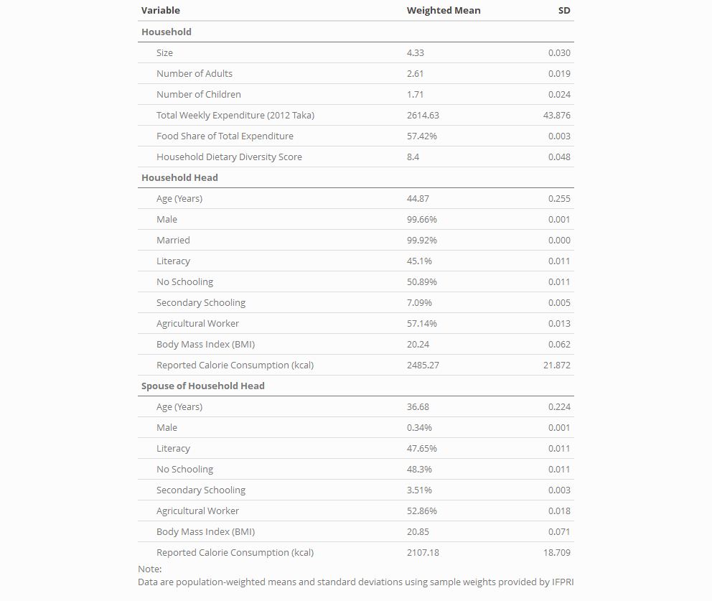

Table 4: Comparison of Weight and Height Reference Standards (IOM, WHO/FAO, India)
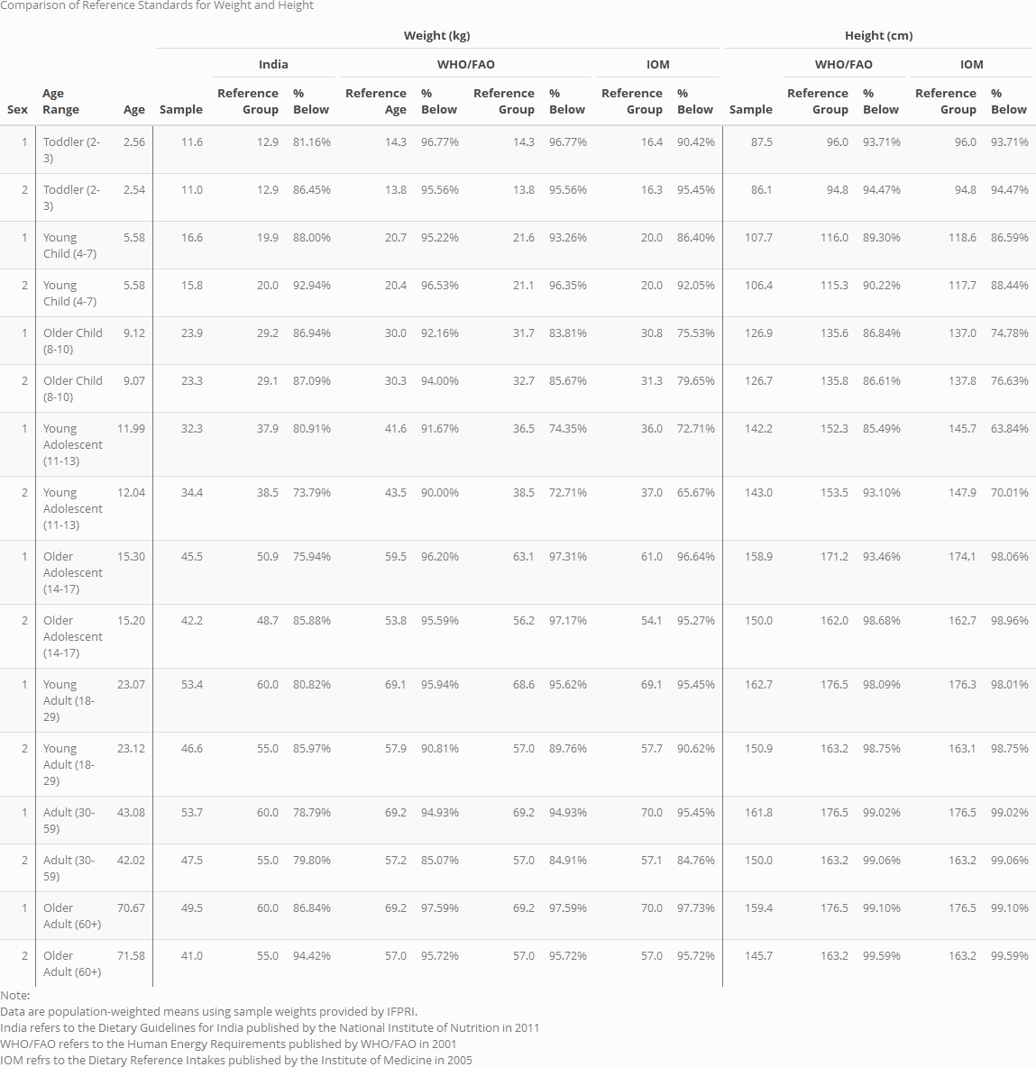

Table 5: Comparison of Adult Equivalents
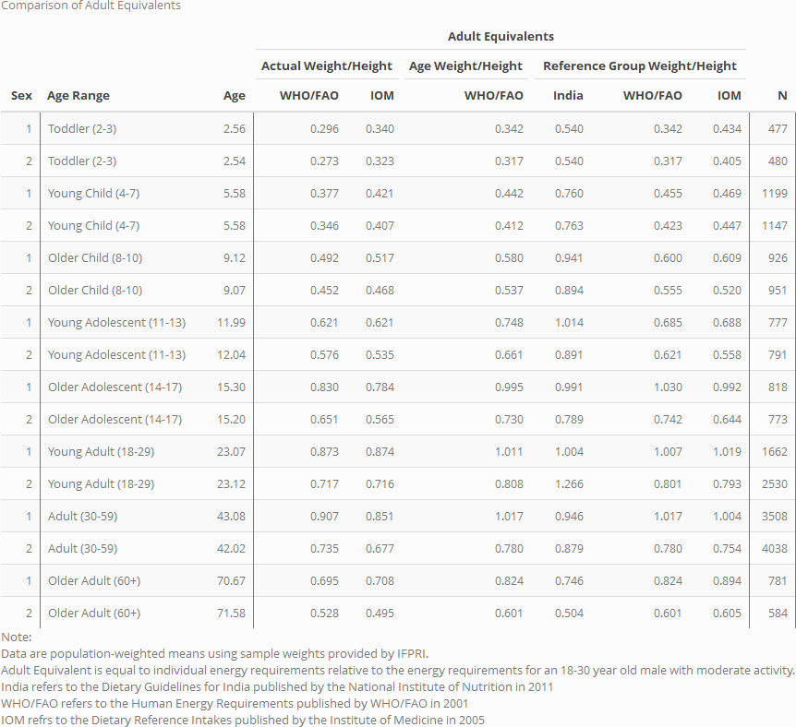

Table 6: Frequency of Energy Inadequacy

Table 7: Intensity of Energy Inadequacy

Table 8: Frequency and Intensity of Protein Inadequacy

Table 9: Frequency and Intensity of Lipid Inadequacy

Table 10: Frequency and Intensity of Carbohydrate Inadequacy

References

Ahmed, A., Ahmad, K., Chou, V., Hernandez, R., Menon, P., Naeem, F., … Yu, B. (2013). The Status of Food Security in the Feed the Future Zone and Other Regions of Bangladesh: Results from the 2011–2012 Bangladesh Integrated Household Survey. Bangladesh Integrated Household Survey, (April), 1–255.
Allen, L.H., A.L. Carriquiry, and S.P. Murphy. (2019). “Perspective: Proposed Harmonized Nutrient Reference Values for Populations.” Advances in Nutrition
Behrman, J. R. (1988). Intrahousehold Allocation of Nutrients in Rural India : Are Boys Favored ? Do Parents Exhibit Inequality Aversion ? Oxford Economic Papers, 40(1), 32–54.
Brown, C., Calvi, R., & Penglase, J. (2018). Sharing the Pie: Undernutrition, Intra-Household Allocation, and Poverty. SSRN Electronic Journal, 1–40.
Bermudez, O. I., Lividini, K., Smitz, M. F., & Fiedler, J. L. (2012). Estimating micronutrient intakes from Household Consumption and Expenditures Surveys (HCES): an example from Bangladesh. Food and Nutrition Bulletin, 33(3 Suppl), 208–213.
Berti, P. R. (2012). Intrahousehold distribution of food: A review of the literature and discussion of the implications for food fortification programs. Food and Nutrition Bulletin, 33(3).
Coates, J., Rogers, B. L., Blau, A., Lauer, J., & Roba, A. (2017). Filling a dietary data gap? Validation of the adult male equivalent method of estimating individual nutrient intakes from household-level data in Ethiopia and Bangladesh. Food Policy, 72, 27–42.
Coates, J., Patenaude, B. N., Rogers, B. L., Roba, A. C., Woldetensay, Y. K., Tilahun, A. F., & Spielman, K. L. (2018). Intra-household nutrient inequity in rural Ethiopia. Food Policy, 81, 82–94.
D’Souza, A., & Tandon, S. (2019). Intrahousehold nutritional inequities in rural Bangladesh. Economic Development and Cultural Change, 67(3), 625–657.
Dietary Guidelines for Indians - A Manual. Hyderabad: NIN; 2011. National Institute of Nutrition.
FAO. (2010). Fats and fatty acids in human nutrition. Rome: Food and Agriculture Organization of the United Nations.
FAO. (2012). FAO / INFOODS Guidelines for Food Matching Version 1.2. Rome.
FAO, WHO, and UNU. 2001. Human energy requirements: Report of a Joint FAO/WHO/UNU Expert Consultation. Rome: Food and Agriculture Organization of the United Nations.
FAO, WHO, and UNU. 2002. Protein and amino acid requirements in human nutrition: report of a joint FAO/WHO/UNU expert consultation. Geneva: World Health Organization.
Fiedler, J. L. (2013). Towards overcoming the food consumption information gap: Strengthening household consumption and expenditures surveys for food and nutrition policymaking. Global Food Security, Vol. 2, pp. 56–63.
Fiedler, J. L., Carletto, C., & Dupriez, O. (2012). Still waiting for Godot? Improving Household Consumption and Expenditures Surveys (HCES) to enable more evidence-based nutrition policies. Food and Nutrition Bulletin, 33(3 Suppl), 242–251.
Fiedler, J. L., Lividini, K., Bermudez, O. I., & Smitz, M. F. (2012). Household Consumption and Expenditures Surveys (HCES): a primer for food and nutrition analysts in low- and middle-income countries. Food and Nutrition Bulletin, 33(3 Suppl), 170–184.
Gopalan, C., Rama Shastri, B., & Balasubramanian, S. . (1987). Nutritive value of Indian Foods. Icmr, p. 117. https://doi.org/10.2307/302397
Haddad, L., Kanbur, R., & Bouis, H. (1994). Intra-Household Inequality and Average Household Well-Being: Evidence on Calorie Intakes and Energy Expenditures from the Philippines. In Developments in Agricultural Economics (Vol. 10, pp. 239–257).
Hagenaars, (1994) Poverty statistics in the late 1980s: research based on micro-data. A.J.M. Statistical Office of the European Communities, Luxembourg (Luxembourg) eng De Vos, K. Asghar Zaidi, M.
Institute of Medicine, Food and Nutrition Board. Dietary Reference Intakes: Applications in Dietary assessment. Washington (DC): National Academies Press; 2000.
Institute of Medicine and National Research Council. 2009. Weight Gain During Pregnancy: Reexamining the Guidelines. Washington, DC: The National Academies Press
Institute of Medicine of the National Academies. 2006. Dietary Reference Intakes: the Essential Guide to Nutrient Requirements J. J. Otten, J. P. Hellwig, and L. D. Meyers, eds. Washington, DC: National Academies Press.
Institute of Medicine of the National Academies. 2005. Dietary Reference Intakes for Energy, Carbohydrate, Fiber, Fat, Fatty Acids, Cholesterol, Protein, and Amino Acids. Washington, DC: National Academies Press.
Institute of Medicine of the National Academies. 2011. Dietary Reference Intakes for Calcium and Vitamin D. Washington, DC: National Academies Press.
Karageorgou, D., Imamura, F., Zhang, J., Shi, P., Mozaffarian, D., & Micha, R. (2018). Assessing dietary intakes from household budget surveys: A national analysis in Bangladesh. PLoS ONE, 13(8), 1–22.
Leroy, J. L., Ruel, M., Sununtnasuk, C., & Ahmed, A. (2018). Understanding the determinants of adolescent nutrition in Bangladesh. Annals of the New York Academy of Sciences, 1416(1), 18–30.
Lividini, K., Fiedler, J. L., & Bermudez, O. I. (2013). Policy implications of using a Household Consumption and Expenditures Survey versus an Observed-Weighed Food Record Survey to design a food fortification program. Food and Nutrition Bulletin, 34(4), 520–532.
Longvah, T., Ananthan, R., Bhaskarachary, K., & Venkaiah, K. (2017). Indian Food Composition Tables. National Institute of Nutrition.
National Academies of Sciences, Engineering, and Medicine 2018. Global Harmonization of Methodological Approaches to Nutrient Intake Recommendations: Proceedings of a Workshop in Brief. Washington, DC: The National Academies Press.
National Academies of Sciences, Engineering, and Medicine 2018. Harmonization of Approaches to Nutrient Reference Values: Applications to Young Children and Women of Reproductive Age. Washington, DC: The National Academies Press.
Pitt, M. M., Rosenzweig, M. R., & Nazmul Hassan, M. (1990). Productivity , Health , and Inequality in the Intrahousehold Distribution of Food in Low- Income Countries. The American Economic Review, 80(5), 1139–1156.
Schneider, K., & Herforth, A. (2020). Software tools for practical application of human nutrient requirements in food-based social science research. Gates Open Research, 1–21.
Shaheen, N. (2013). Food Composition Table for Bangladesh. Institute of Nutiriton and Food Science: Center for Advanced Research in Sciences. University of Dhaka, Bangladesh.
Steeves, J. A., Tudor-Locke, C., Murphy, R. A., King, G. A., Fitzhugh, E. C., & Harris, T. B. (2015). Classification of occupational activity categories using accelerometry: NHANES 2003-2004. International Journal of Behavioral Nutrition and Physical Activity, 12(1).
Sununtnasuk, C., & Fiedler, J. L. (2017). Can household-based food consumption surveys be used to make inferences about nutrient intakes and inadequacies? A Bangladesh case study. Food Policy, 72, 121–131.
US Department of Agriculture. 2018. USDA National Nutrient Database for Standard Reference, Legacy (2018). Beltsville, Maryland: USDA Agricultural Research Service Nutrient Data Laboratory.
USDA. (2007). USDA Table of Nutrient Retention Factors, Release 6. National Academy Press, 18. Retrieved from www.nal.usda.gov/fnic/foodcomp/Data/retn6/retn06.pdf
WHO Multicentre Growth Reference Study Group. 2006. World Health Organization child growth standards: Methods and development. Geneva: World Health Organization

Appendix
From Pablo Jose Ordonez Morales to Everyone: 12:34 PM
http://ibread.org/bread/conferences/bread-40-conference
From Ben Wood to Everyone: 12:41 PM
have you run across a lot of studies that use anthropometric measure of adults?
From Tisorn to Everyone: 12:46 PM
Another you might consider is the food insecurity experience scale (FIES) - the two most recent SOFI reports have published sex-disaggregated food insecurity measures by country
From Ben Wood to Everyone: 01:03 PM
sorry everyone, back to work meetings. interesting topic. might want to motivate the research a bit more
From Armand Tossou to Everyone: 01:19 PM
What Machine Learning techniques do you have in mind?
From hemant to Everyone: 01:25 PM
Comments from Pallavi: 1. Your motivation is not clear. Why are you writing this paper? What is the problem in current ways of measurement? How will your analysis change the way we should think about measuring nutrition? These are some of the questions you need to answer; 2. The flowcharts are unhelpful and actually distracting; 3. Tell us your research question upfront. 20 mins into the presentation I was still trying to figure out what it was; 4. Don’t say let’s leave it to nutritionists. Economists can use nutritionist-approved methods to measure things; 5. Be careful when you say nutritionists recommend using BMI for something. Most nutritionists complain about how everyone tends to overuse BMI

In 2011, the IOM was renamed the National Academies of Science, Engineering, and Medicine (NASEM) and subsequent reports are published under NASEM. The European Food Safety Authority (EFSA) also sets nutrient reference values.
Note that the methods for measuring inadequacy for iron also differ from most other nutrients (see CITE).

